Project Description

As shown in Figure 1 in the Project Motivation form the current configuration of the Information & Link Network ( ILN ) of the Minufiya University and its branches is build on a link of 2Mbps bandwidth (between FRCU and ILN central site) , HDSL modems, 3700, 2601, and 2501 CISCO Routers, 4005 Core Switch, 3COM Edge Switches, Unix Server, Pentium III, and Pentium IV PCs.

However, the objectives methodology of the project are: Upgrade the bandwidth up to E3 -----> Gigabit between the FRCU and ILN that is associated to an upgrade of the extra, inter, and intra BW of the links between the ILN and its branches. Simultaneously, upgrade the hardware of the main devices such as (Routers, Modems, Switches, Hubs, Servers, PCs, and etc.) with the latest technology, upgrade the software which applicable to the services based on e-technology such as (e-learning, e-library, e-education, …..etc.). Draw the mechanisms and strategies of using the Information Technology which can be useful for all the users. Draw the configuration of the security policies and firewalls to protect the Information Technology from attacks and hackers. Upgrade to the date of the anti viruses and worms for protection the IT from damage or lost.
The project outputs/outcomes are: Improve the access to the Internet and also, to the distributed Local Computer Networks. Guarantee to support newly Internetworking devices, equipment’s and up to date services based on e-technologies. Improve and enhancing research and education strategies.
The assumptions and risks of the project are: The delay to start of the implementation to the project which have been pointed out above for any reason. The bad routine for finishing and approve some forms of process for buying and implement something belongs to the work which have been mentioned above. The delay of some companies for finishing their work because of either bad routine of the rules or less experience with the work !!!!!!

The following Figure 2 and Figure 3 show the connection between the FRCU with ILN, and the connection between the ILN with its sub-sites, and the connection between the ILN's sub-sites with the ILN's sub-sub sites (we'll follow the same topology for extending and adding of the new sub-sites or sub-sub-sites to the ILN configuration).

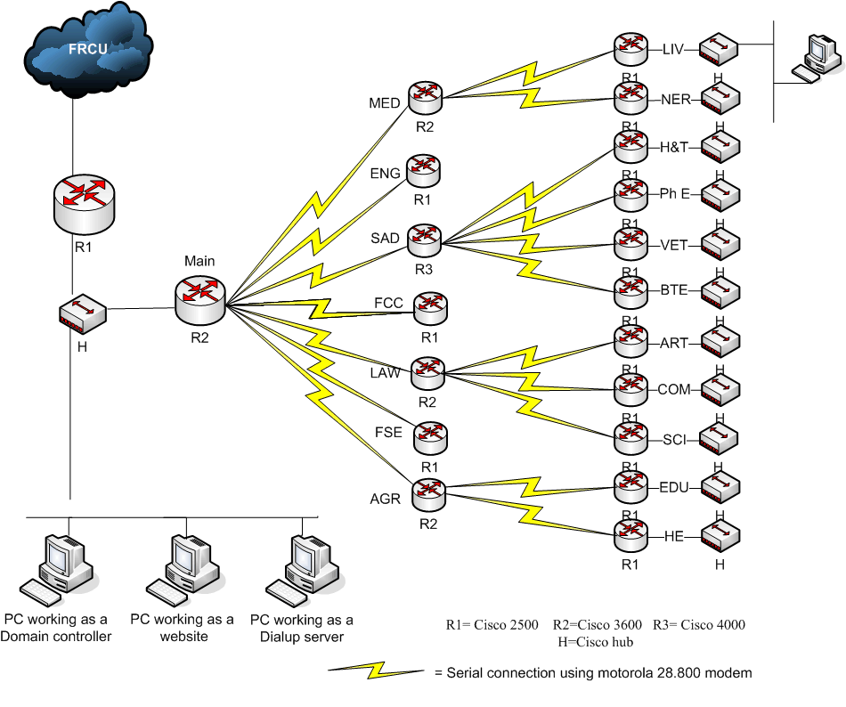

Figure 2 The Connection between the FRCU with ILN and its Branches

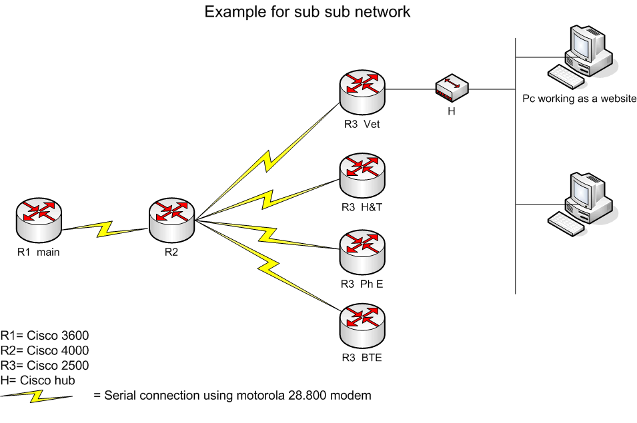

Figure 3 The Connection between the sub-sub site of the ILN’s branches.

The Menoufiya Information and Link Network (ILN)
Consists of the following

(1) Information and Link Network (ILN) ) (Central Site, Shebin El-Kom),
(2) Faculty of Agriculture (Shebin El-Kom),
(3) Faculty of Medicine (Shebin El-Kom),
(4) Faculty of Law (Shebin El-Kom),
(5) Faculty of Commerce (Shebin El-Kom),
(6) Faculty of Science (Shebin El-Kom),
(7) Faculty of Arts (Shebin El-Kom),
(8) Faculty of Nursing (Shebin El-Kom),
(9) Faculty of Engineering (Shebin El-Kom),
(10) Faculty of Home Economic (Shebin El-Kom),
(11) Faculty of Education (Shebin El-Kom),
(12) Faculty of Information & Computers (Shebin El-Kom),
(13 ) National Institute of Liver Disease (Shebin E-Kom),
(14)The Menoufiya University General Service Center (Shebin El-Kom),
(15) The Menoufiya University General Hospital (Shebin El-Kom),
(16) The Menoufiya University Health Care Insurance (Shebin El-Kom),
(17) Faculty Electronic Engineering (Menouf),
(18 ) Faculty of Physical Education (Ashemon),
(19) Genetic Engineering and Biotechnology Research Institute (Sadat City)
(20) Faculty of Physical Education (Sadat City),
(21) Faculty of Veterinary Medicine (Sadat City),
(22) Desert Environment Research Institute (Sadat City),
(23) Faculty of Tourism and Hotels (Sadat City),
(24) Faculty of Law (Sadat City Branch),
(25) Faculty of Education (Sadat City Branch),
(26) Faculty of Commerce (Sadat City Branch),

N.B.

The following new branches have not yet any connection to the Internet. However, it is very necessary to be connected to the Internet, therefore we’ve considered them with the upgrading of the Infrastructure as a new branches, (i.e. these are needing for complete internetworking equipments, (modems, routers, switches, cables…etc.)):

1- Faculty of Law (Sadat City Branch),
2- Faculty of Education (Sadat City Branch),
3- Faculty of Commerce (Sadat City Branch),
4- The Menoufiya University General Service Center (Sadat City),
5- Desert Environment Research Institute (Sadat City).
These will connected as a sub-sites and sub-sub-sites depends upon the distances between them, and will follow the same topology and configuration we are using with the previous established sub-sites and sub-sub-sites of the hole network.
The following Figure 4 and Figure 5 show the complete block diagrams of ILN and its branches before and after the ICTP Project.
Figure 4 Block Diagram of ILN and its Branches Before the ICTP Project


Fac. Phy. Edu. Sub Sub- Site
FRCU

Fac. Science Sub Sub
- Site Shebin

Fac. Elec. Eng. Sub Site Menouf

Sadat City Sub-Site

ILN (Central Site) Shebin
Fac. Eng Sub- Site Shebin
Fac. Spec. Edu. Sub- Site Ashmon
Fac. Vet.Med. Sub Sub- Site
Fac. H&T Sub Sub- Site
Inst.. G.E. B. Sub Sub- Site
Inst. Liver. Sub-Sub-Site Shebin
Fac. Art. Sub- Site Shebin
Fac. Com. Sub Sub- Site Shebin
Fac. Nursing Sub Sub- Site Shebin
Fac. Med. Sub- Site Shebin
Fac. Law Sub Sub- Site Shebin
Fac. Info & Comp Sub- Site Shebin
Fac. Agr. Sub- Site Shebin
Fac. Edu.
Sub-Sub- Site Shebin
Fac. Hom. Eco. Sub Sub- Site Shebin

E1 Circuits (connected between FRCU and ILN and between ILN and some
Sub-sites which constructed outside Shebin El-Kom City).

Data Cables through PSTN ( connected between ILN and some sub-sites
which constructed inside Shebin El-Kom City ).

Internal Connection Using UTP Cat.5e Cables (connected between the ILN's
Sub-sites and ILN's sub-sub-sites which constructed near the sub-sites
distributed at Shebin El-Kom City or Sadat City).

N.B: The full descriptions and details about the current equipments included within the central site, each nodes and branches site mentioned in details in the following page.

Figure 4 Complete Configuration for Current Menoufia University Network before ICTP (ILN and its Branches Distributed at Shebin El-Kom City, Minuf City, Ashmon City, and Sadat City
Figure 5 Block Diagram of ILN and its Branches after the ICTP Project

Fac. Phy. Edu. Sub Sub- Site
FRCU
Fac. Science Sub Sub
- Site Shebin

Fac. Elec. Eng. Sub Site Menouf

Sadat City Sub-Site

ILN (Central Site) Shebin
Fac. Eng Sub- Site Shebin
Fac. Spec. Edu. Sub- Site Ashmon
Fac. Vet.Med. Sub Sub- Site
Fac. H&T Sub Sub- Site
Inst.. G.E. B. Sub Sub- Site
Inst. Liver. Sub-Sub-Site Shebin
Fac. Art. Sub- Site Shebin
Fac. Com. Sub Sub- Site Shebin
Fac. Nursing Sub Sub- Site Shebin
Fac. Med. Sub- Site Shebin
Fac. Law Sub Sub- Site Shebin
Fac. Info & Comp Sub- Site Shebin
Fac. Agr. Sub- Site Shebin
Fac. Edu.
Sub-Sub- Site Shebin
Fac. Hom. Eco. Sub Sub- Site Shebin
Fac. Law New Sub Sub- Site
Fac. Com New Sub Sub- Site

Fac. Edu New Sub Sub- Site

Serv. Cent New Sub Sub- Site

Fiber Optic Connected between FRCU and ILN
Ins. Env.R New Sub Sub- Site

E1 Circuits (connected between ILN and some
Sub-sites which constructed outside Shebin El-Kom City).

Data Cables through PSTN ( connected between ILN and
some sub-sites which constructed inside Shebin El-Kom City ).

Internal Connection Using UTP Cat.5e Cables (connected between the
ILN's Sub-sites and ILN's sub-sub-sites which constructed near the
sub-sites distributed at Shebin El-Kom City or Sadat City).
N.B: The full descriptions and details about the current equipments included within the central site, each nodes and branches site mentioned in details in the following page.

Figure 5 New Configuration for Menoufia University Network after Development with ICTP (ILN and its Branches Distributed at Shebin El-Kom City, Menof City, Ashmon City, and Sadat City)

